Assignment 2: Design Thinking

First and Foremost i will suggest to construct a roundabout on the intersection,

Roundabouts will avoid chanes of deadlock like there nay be 4 vehicles coming at the same time towards each other,

Seondly at intersections where there are schools nearby,

i would install the Max Speed to be between 20kmph and no honking,

For traditional school incoming and outgoing hours, i would install a children crossing flag, which will be taken down at other times,

On these children crossings, vehicles have to wait util children cross the entire road.

For Areas which are rushy and have busy pedestrial walkaways as welll, i would install humps to lower down vehicle speed and avoid accidents,

Will Install outdoor convex mirrors at turnings

And most importantly, building a bridge on top such that the vehicles that dont want to turn will take the bridge directly and not stop at the intersection to

increase traffic,

Will have seperate altogether for buses so that other vehicles like bikes dont interfere while passengers boarding or getting down the bus,

Record traffic(vehicle) counts at intersections to analyse how traffic signal timings,

Have dedicated pathway for pedestrians just besides the bus way and have regulated traffic timings based on the vehicle count

AERIAl VIEW :

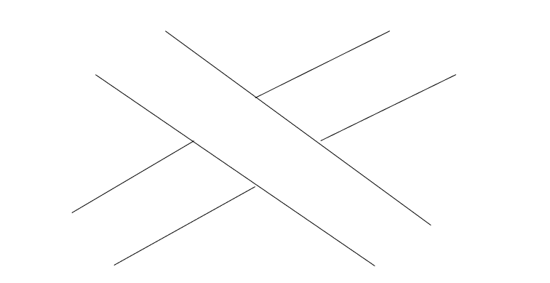

GROUND VIEW:

